List Positions and Updates

Look at this code:
supplies = ["pencil", "book", "tape"]
position = int(input("Position 0 to 2: "))
print("Old item:", supplies[position])
replacement = input("Replacement item: ")
supplies[position] = replacement
print("Updated list:", supplies)

What do you think this code will display?
Click or tap here to enter text.

Run the code. Compare the result with your prediction:
Click or tap here to enter text.

Let’s investigate! Answer the questions below:
- Why is the first list position 0 rather than 1?
Click or tap here to enter text.

- What happens if the user enters position 3 for a list containing three items?
Click or tap here to enter text.

- Why must the position input be converted with int() before it is used inside square brackets?
Click or tap here to enter text.

- How does index assignment change one item without changing the length of the list?
Click or tap here to enter text.

List Positions and Updates

Look at this code:
supplies = ["pencil", "book", "tape"]
position = int(input("Position 0 to 2: "))
print("Old item:", supplies[position])
replacement = input("Replacement item: ")
supplies[position] = replacement
print("Updated list:", supplies)

Use the code above to help you. After completing each challenge below, run your program to test that it works correctly. Save each completed challenge program in a new file.

Programming Challenges

Challenge 1
Replace the item at position 2 with scissors. The final list must display pencil, book and scissors in that order.
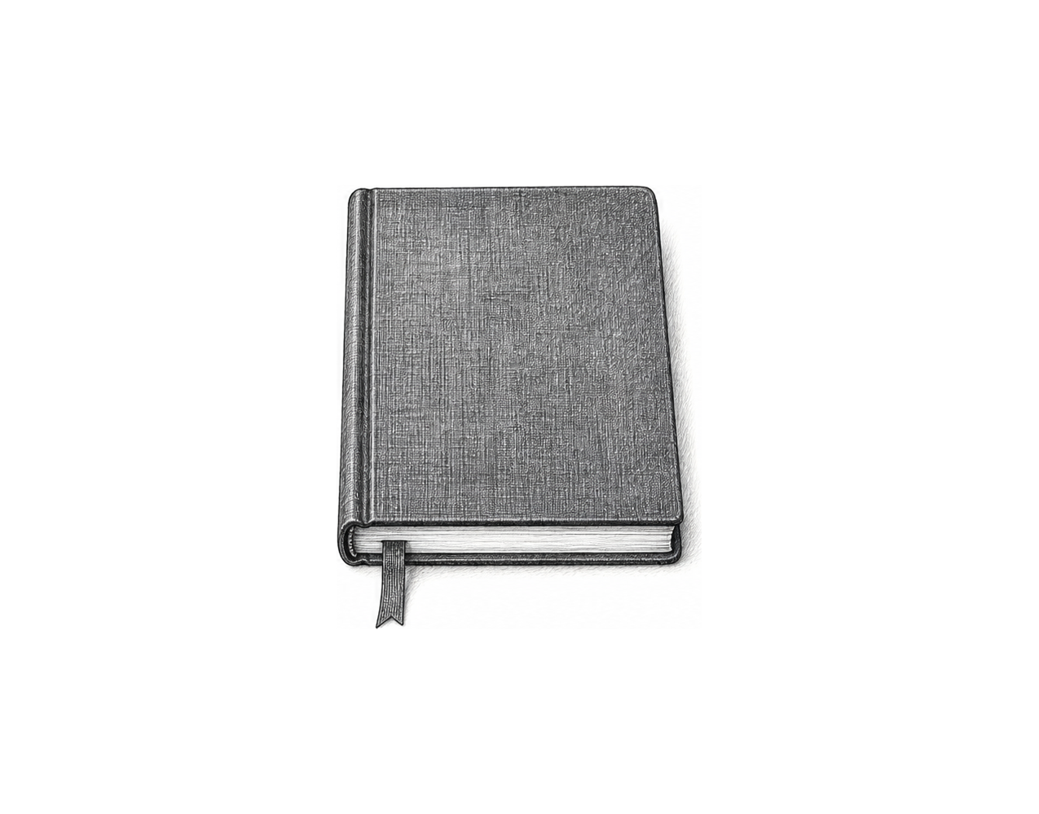

Challenge 2
After the replacement, ask for a second valid position and display the item currently stored there. For 1/folder then 1, the selected item must be folder.

Challenge 3
Build a three-stop route editor. Start with three place names, ask which valid position to change and the new place, then display the first stop and the complete updated route.

List Positions and Updates

Fix the code!

This code has errors! Look closely at the code to find the problems:

supplies = ["pencil", "book", "tape"]
print("Old item:", supplies(3))
supplies(1) = "folder"
print(supplies)

Rewrite the whole program in the box below with fixes to the errors.
Click or tap here to enter text.

After you are confident that you fixed all the errors, copy the code from the box and run it.

Did it work correctly on your first try? Did you find all the errors?
Click or tap here to enter text.

